LAB 11

Program to illustrate Layout Manager

OBJECTIVE:

The objective of the following program is to illustrate various layout manager operations:

*package* com.company;  
*import* org.w3c.dom.Text;  
  
*import* javax.swing.*;  
*import* java.util.Scanner;  
*import* java.awt.*;  
*import* java.awt.event.*;  
*class* flowLayout *extends* Frame{  
 Button **b1**, **b2**, **b3**, **b4**, **b5**, **b6**, **b7**, **b8**, **b9**, **b10**;  
 *public* flowLayout(){  
 *super*("Flow Layout Demo");  
 **b1**=*new* Button("One");  
 **b2**=*new* Button("Two");  
 **b3**=*new* Button("Three");  
 **b4**=*new* Button("Four");  
 **b5**=*new* Button("Five");  
 **b6**=*new* Button("Six");  
 **b7**=*new* Button("Seven");  
 **b8**=*new* Button("Eight");  
 **b9**=*new* Button("Nine");  
 **b10**=*new* Button("Ten");  
 FlowLayout fl=*new* FlowLayout();  
 fl.setAlignment(FlowLayout.***CENTER***);  
 fl.setHgap(50);  
 setLayout(fl);  
 add(**b1**);  
 add(**b2**);  
 add(**b3**);  
 add(**b4**);  
 add(**b5**);  
 add(**b6**);  
 add(**b7**);  
 add(**b8**);  
 add(**b9**);  
 add(**b10**);  
 }  
}  
*class* borderLayout *extends* Frame{  
 Button **b1**, **b2**, **b3**, **b4**, **b5**, **b6**, **b7**, **b8**, **b9**, **b10**;  
 *public* borderLayout(){  
 *super*("Border Layout Demo");  
 **b1**=*new* Button("One");  
 **b2**=*new* Button("Two");  
 **b3**=*new* Button("Three");  
 **b4**=*new* Button("Four");  
 **b5**=*new* Button("Five");  
 **b6**=*new* Button("Mon");  
 **b7**=*new* Button("Tue");  
 **b8**=*new* Button("Wed");  
 **b9**=*new* Button("Thru");  
 **b10**=*new* Button("Fri");  
 add(**b2**, BorderLayout.***WEST***);  
 add(**b3**, BorderLayout.***EAST***);  
 add(**b4**, BorderLayout.***NORTH***);  
 add(**b5**, BorderLayout.***SOUTH***);  
 Panel p=*new* Panel(*new* GridLayout());  
 p.add(**b6**);  
 p.add(**b7**);  
 p.add(**b8**);  
 p.add(**b9**);  
 p.add(**b10**);  
 add(p, BorderLayout.***CENTER***);  
  
 }  
}  
*class* gridLayout *extends* Frame{  
 Button **b1**, **b2**, **b3**, **b4**, **b5**, **b6**, **b7**, **b8**, **b9**, **b10**;  
 *public* gridLayout(){  
 *super*("Grid Layout Demo");  
 **b1**=*new* Button("One");  
 **b2**=*new* Button("Two");  
 **b3**=*new* Button("Three");  
 **b4**=*new* Button("Four");  
 **b5**=*new* Button("Five");  
 **b6**=*new* Button("Six");  
 **b7**=*new* Button("Seven");  
 **b8**=*new* Button("Eight");  
 **b9**=*new* Button("Nine");  
 **b10**=*new* Button("Ten");  
 GridLayout gl=*new* GridLayout(4, 3);  
 setLayout(gl);  
 add(**b1**);  
 add(**b2**);  
 add(**b3**);  
 add(**b4**);  
 add(**b5**);  
 add(**b6**);  
 add(**b7**);  
 add(**b8**);  
 add(**b9**);  
 add(**b10**);  
 }  
}  
*class* gridBagLayout *extends* Frame{  
 Button **b1**, **b2**, **b3**, **b4**, **b5**, **b6**, **b7**, **b8**, **b9**, **b10**;  
 *public* gridBagLayout(){  
 *super*("GridBag Layout Demo");  
 **b1**=*new* Button("One");  
 **b2**=*new* Button("Two");  
 **b3**=*new* Button("Three");  
 **b4**=*new* Button("Four");  
 **b5**=*new* Button("Five");  
 **b6**=*new* Button("Six");  
 GridBagLayout gb=*new* GridBagLayout();  
 GridBagConstraints gbc=*new* GridBagConstraints();  
 setLayout(gb);  
 gbc.**gridx**=1;  
 gbc.**gridy**=1;  
 add(**b1**, gbc);  
 gbc.**gridx**=2;  
 gbc.**gridy**=2;  
 add(**b2**, gbc);  
 gbc.**gridx**=3;  
 gbc.**gridy**=3;  
 add(**b3**, gbc);  
 gbc.**gridx**=4;  
 gbc.**gridy**=4;  
 add(**b4**, gbc);  
 gbc.**gridx**=5;  
 gbc.**gridy**=5;  
 add(**b5**, gbc);  
 gbc.**gridx**=6;  
 gbc.**gridy**=6;  
 add(**b6**, gbc);  
 }  
}  
*class* cardLayout *extends* Frame {  
 JFrame **frame** = *new* JFrame("CardLayout demo");  
 JPanel **panelCont** = *new* JPanel();  
 JPanel **panelFirst** = *new* JPanel();  
 JPanel **panelSecond** = *new* JPanel();  
 JButton **buttonOne** = *new* JButton("Switch to second panel/workspace");  
 JButton **buttonSecond** = *new* JButton("Switch to first panel/workspace");  
 CardLayout **cl** = *new* CardLayout();  
  
 *public* cardLayout() {  
 **panelCont**.setLayout(**cl**);  
 **panelFirst**.add(**buttonOne**);  
 **panelSecond**.add(**buttonSecond**);  
 **panelFirst**.setBackground(Color.***BLUE***);  
 **panelSecond**.setBackground(Color.***GREEN***);  
  
 **panelCont**.add(**panelFirst**, "1");  
 **panelCont**.add(**panelSecond**, "2");  
 **cl**.show(**panelCont**, "1");  
  
 **buttonOne**.addActionListener(*new* ActionListener() {  
 @Override  
 *public void* actionPerformed(ActionEvent arg0) {  
 **cl**.show(**panelCont**, "2");  
 }  
 });  
  
 **buttonSecond**.addActionListener(*new* ActionListener() {  
 @Override  
 *public void* actionPerformed(ActionEvent arg0) {  
 **cl**.show(**panelCont**, "1");  
 }  
 });  
 **frame**.add(**panelCont**);  
 **frame**.setDefaultCloseOperation(JFrame.***DISPOSE_ON_CLOSE***);  
 **frame**.pack();  
 **frame**.setVisible(*true*);  
 }  
}  
 *public class* layoutManager {  
 *public static void* main(String[] args) {  
 flowLayout f = *new* flowLayout();  
 f.setSize(500, 500);  
 f.setVisible(*true*);  
 borderLayout b = *new* borderLayout();  
 b.setSize(500, 500);  
 b.setVisible(*true*);  
 gridLayout g = *new* gridLayout();  
 g.setSize(500, 500);  
 g.setVisible(*true*);  
 gridBagLayout gb = *new* gridBagLayout();  
 gb.setSize(500, 500);  
 gb.setVisible(*true*);  
 cardLayout cd = *new* cardLayout();  
 }  
 }

OUTPUT :

1. Flow Layout :

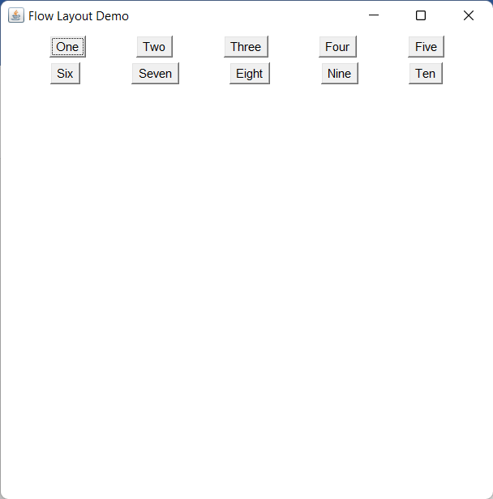

2. Border Layout(With a Panel in Centre) :

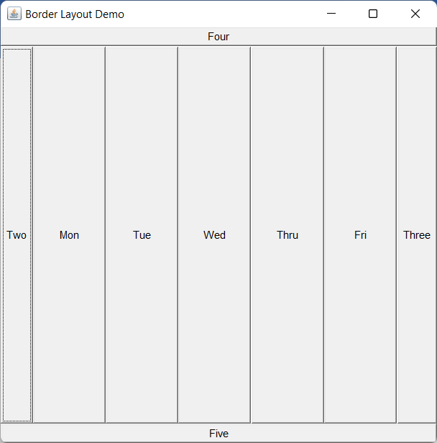

3. Grid Layout :

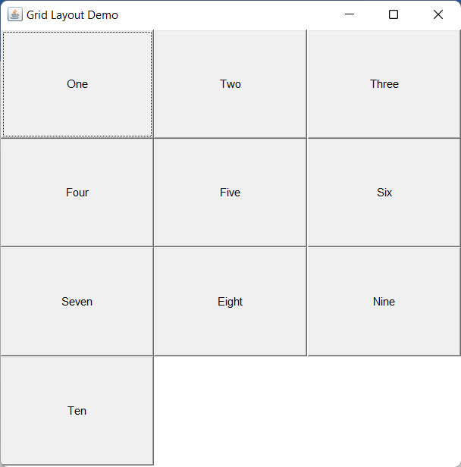

4. GridBag Layout :

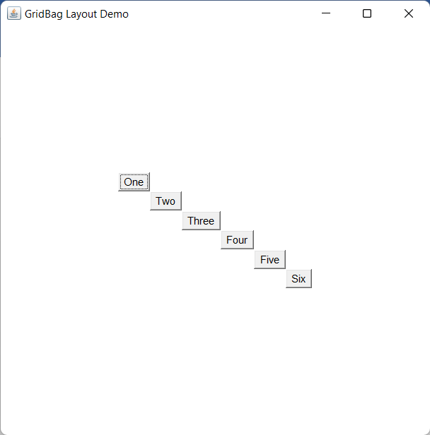

5. Card Layout :

a) 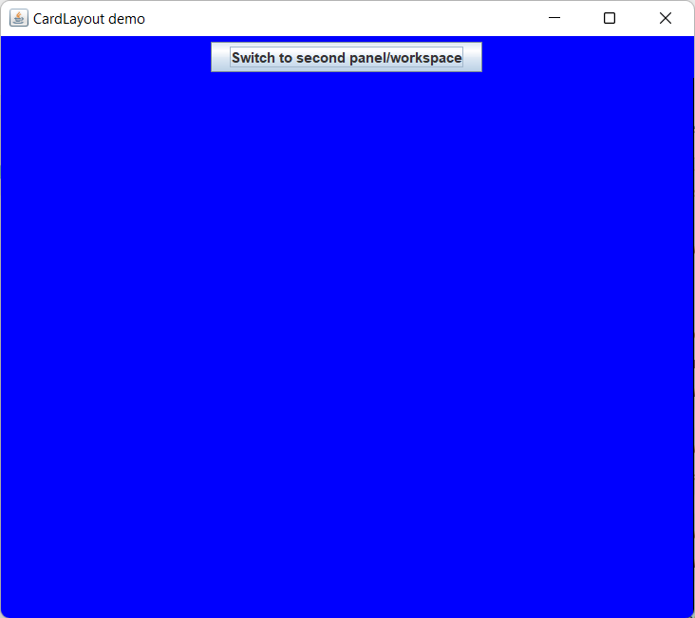 b) 